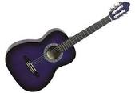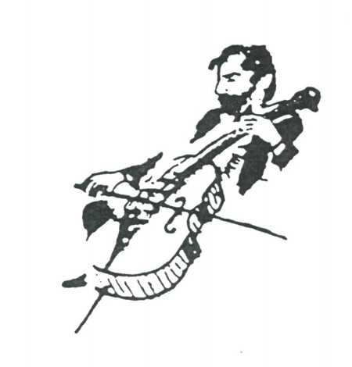

2nd Annual Gasse School of Music
Summer Guitar Camp

When: Monday July 10 to Friday July 14
Time: 9am – noon.
Location: Gasse School of Music
7641 Polk St.
Forest Park, IL 60130
Age: 8 to 12 years old.
Level: Beginners, no experience required.
Cost: $150 for one child, $130 each additional sibling.
Guitar rental extra.
What to expect:
-An international level guitar teacher
- Jazz and Pop chords
- Music related games
- Performance from the teacher
- Reading concepts (tablature and Standard)
- Grand finale student’s performance
- Snacks and GSM T-Shirt

For more information:
www.gasseschoolofmusic.org
(708) 488-8117
Space is limited. Register now!!!

